**Section 1:- Generate unsigned apk file from github.**

Step 1: open project github repository.

Step 2: go to the **Action** section of repository. All the workflows

& it’s results are listed here

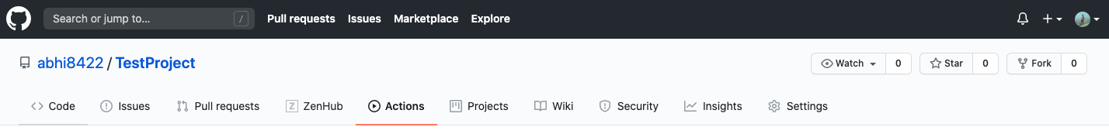

Step 3:click on the workflow “Create signed apk manually”

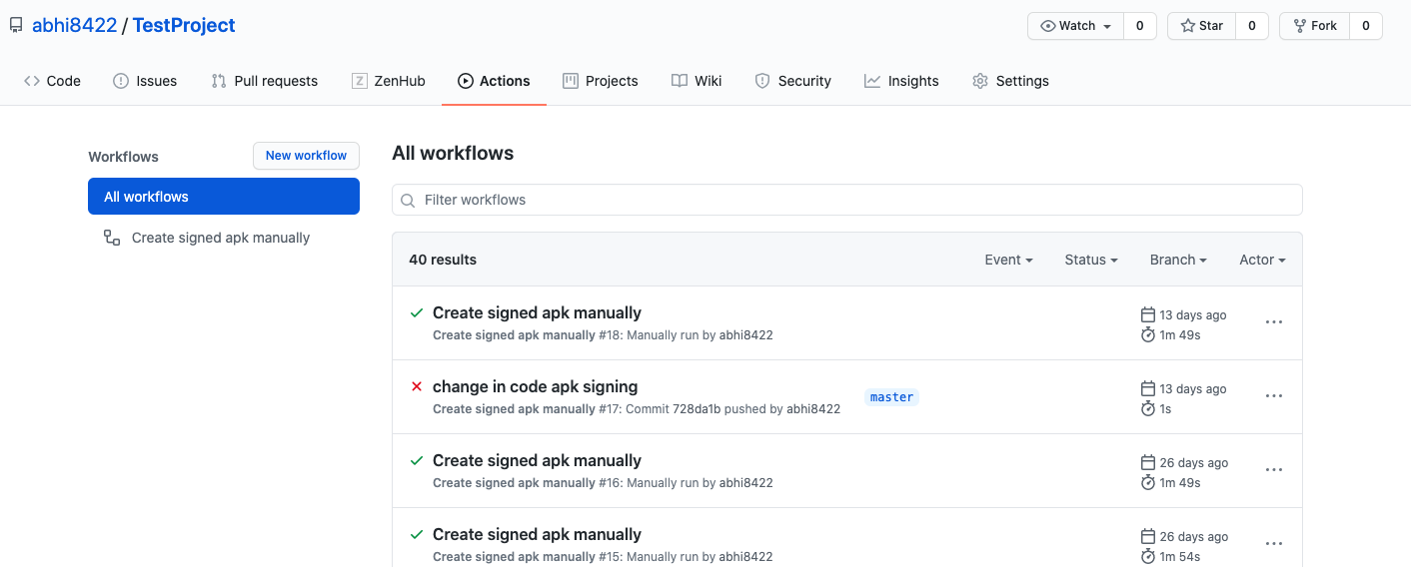

Step 4: Then you will redirect to “Create signed apk manually” workflow page. On the right side there is option **Run Workflow** click on it then select the latest version branch and click on **Run**

**Workflow** button.

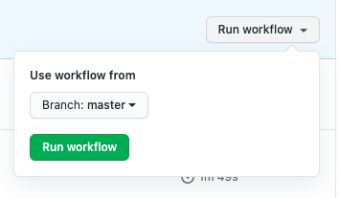

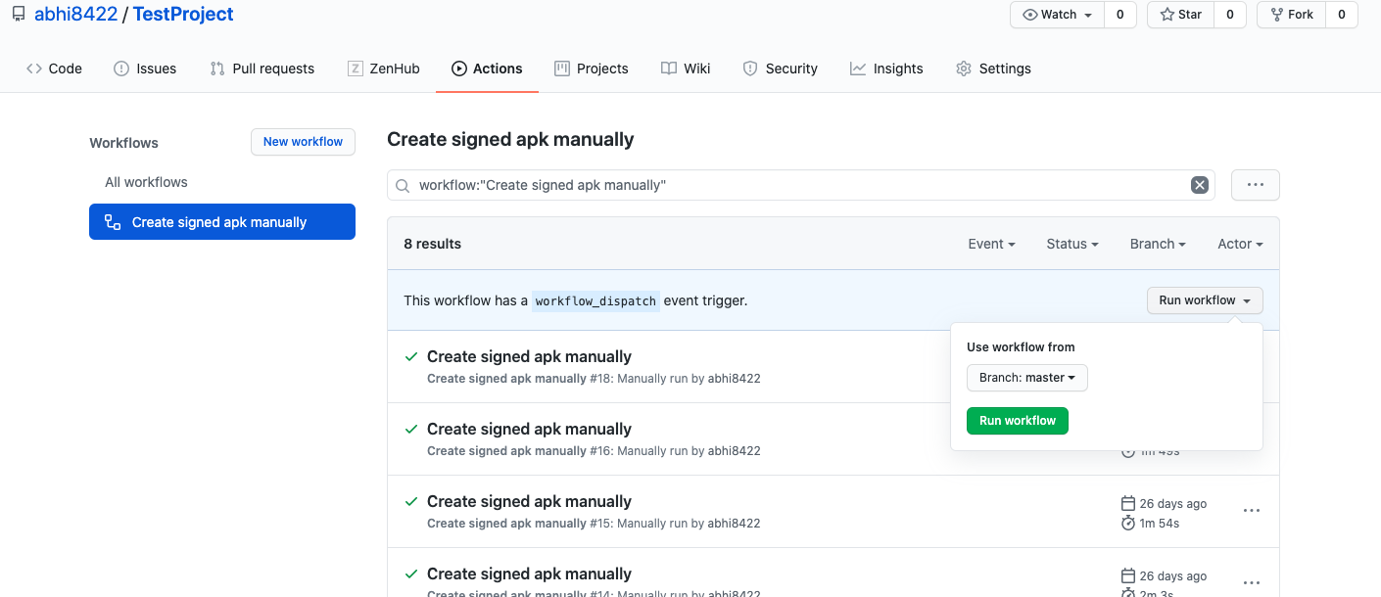

After that workflow will start running. if the workflow is run successfully we can see the green tick mark otherwise it will set to red cross mark.

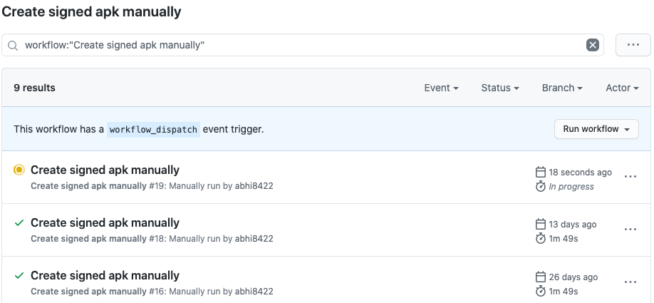

Step 6: click on workflow, then click “app” it will download apk zip file.

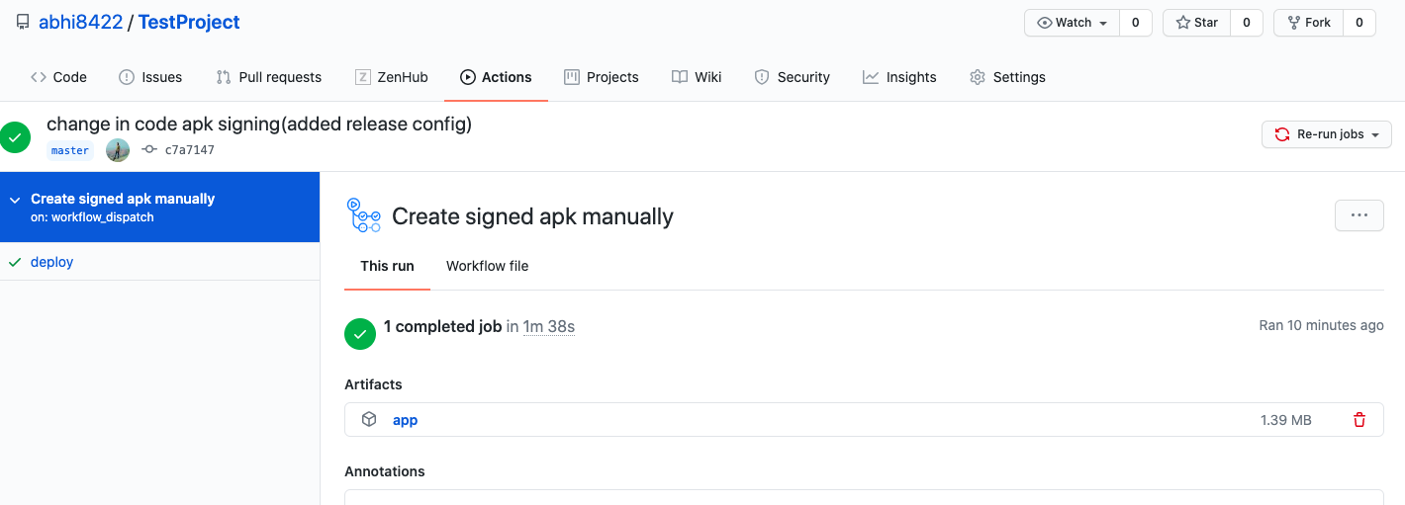

**Section 2:-Sign the apk manually using commands.**

**Prerequisite -> Android SDK & put Extranet.jks (key file) file inside** “**C:\Users\Sudarshan\AppData\Local\Android\Sdk\build-tools\29.0.1**” **path.**

**Step 1: set cmd path to**

C:\Users\Sudarshan\AppData\Local\Android\Sdk\build-tools\29.0.1

**Step 2: run below command**

“C:\Users\Sudarshan\AppData\Local\Android\Sdk\build-tools\29.0.1\zipalign -v -p 4 C:\Users\Sudarshan\Desktop\app-release-unsigned.apk app-release-unsigned-aligned.apk ”

*replace the highlighted path to apk file path downloaded from gihub with file name

*this cmd generate the aligned apk file inside Android\Sdk\build-tools\29.0.1\

**Step 3: run below command**

“C:\Users\Sudarshan\AppData\Local\Android\Sdk\build-tools\29.0.1\apksigner sign --ks Extranet.jks --out C:\Users\Sudarshan\Desktop\my-app-release.apk app-release-unsigned-aligned.apk**”**

*signed apk will be stored at highlighted path (we can change the highlighted path of this command)